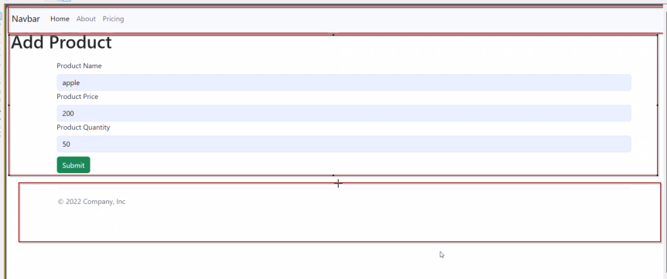

Components

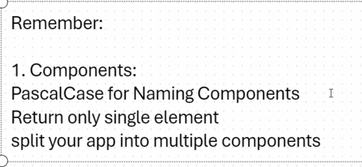

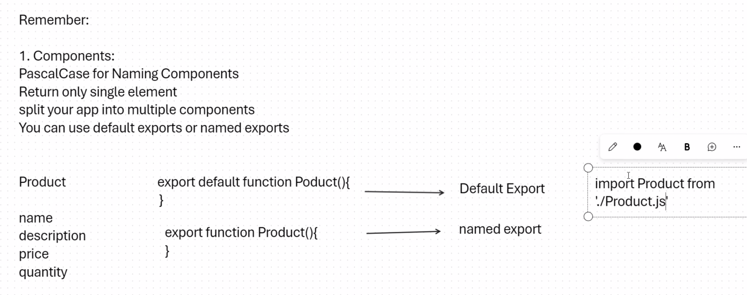

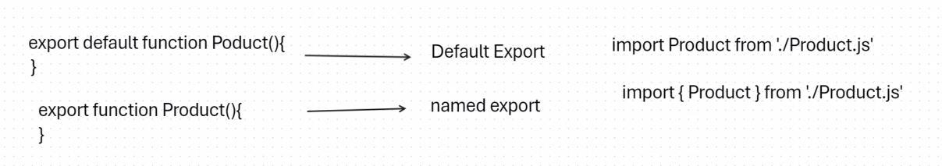

Install bootstrap first

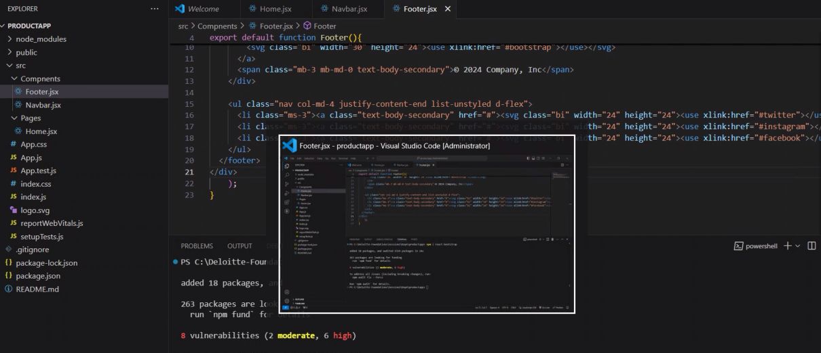

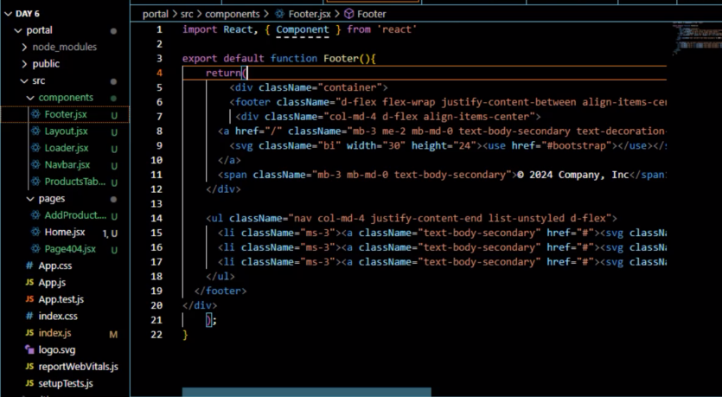

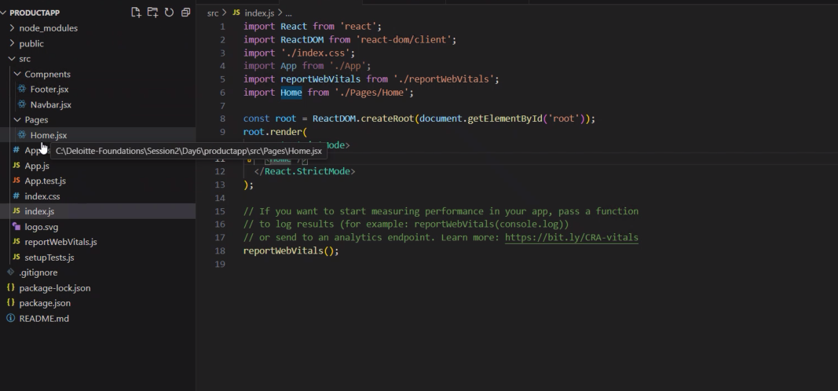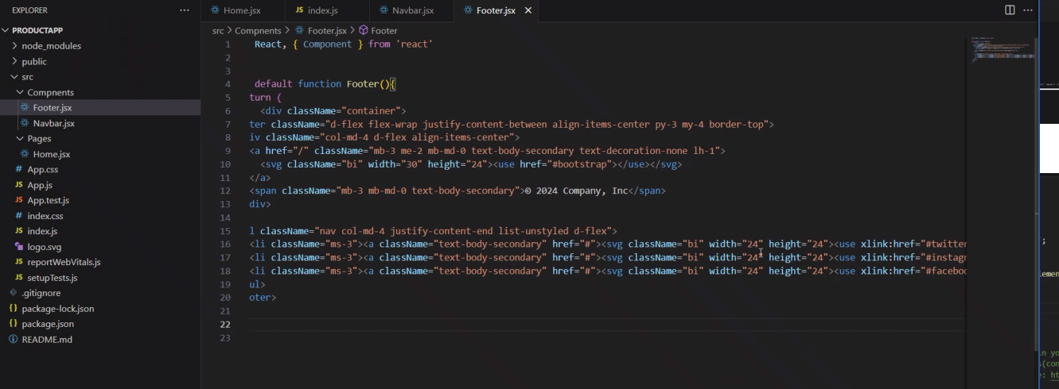

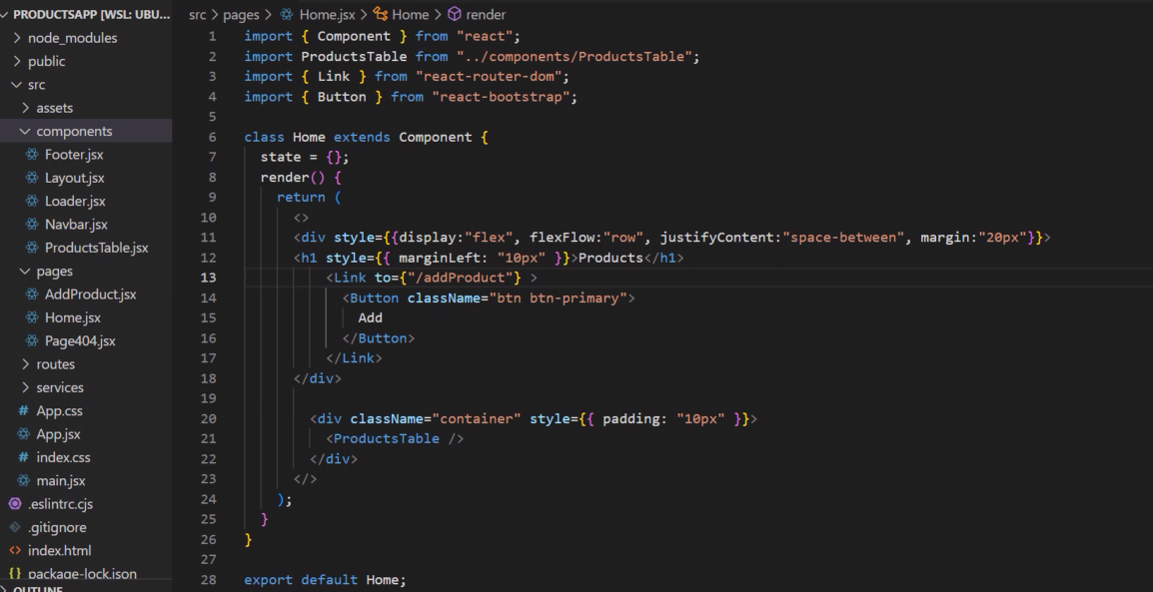

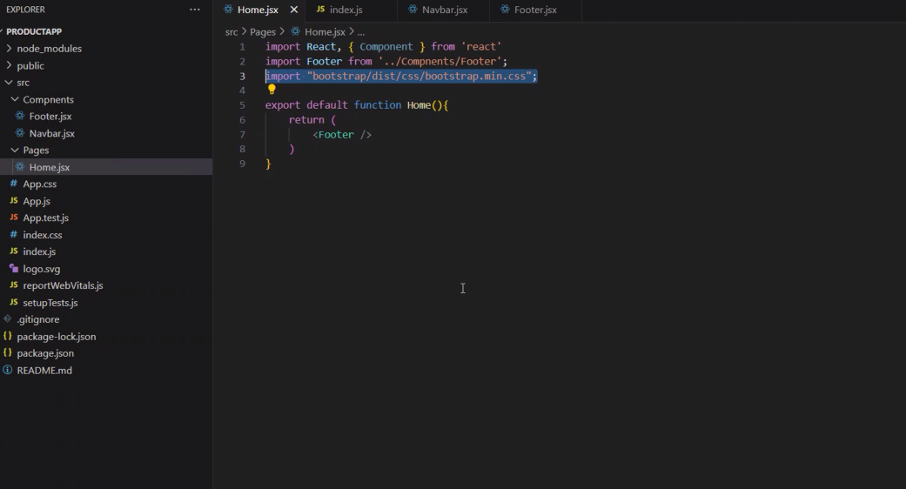

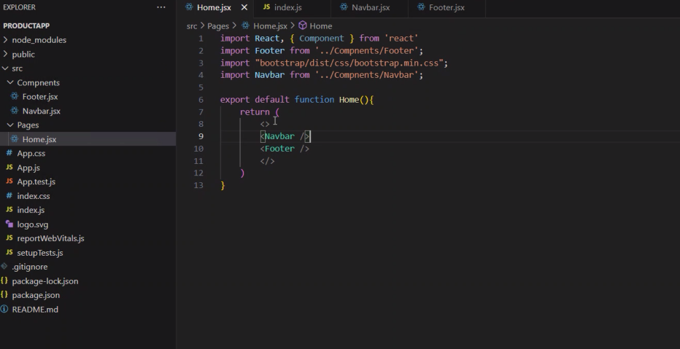

Productstable.jsx

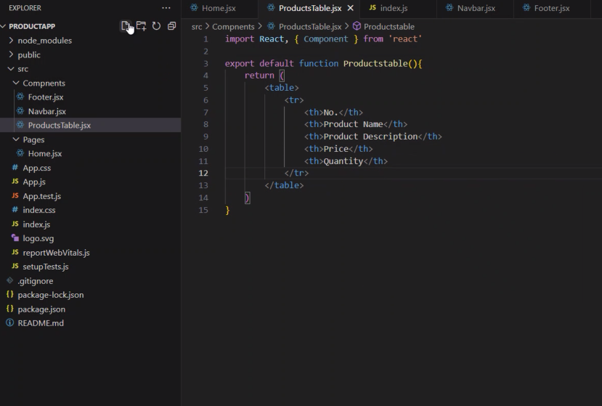

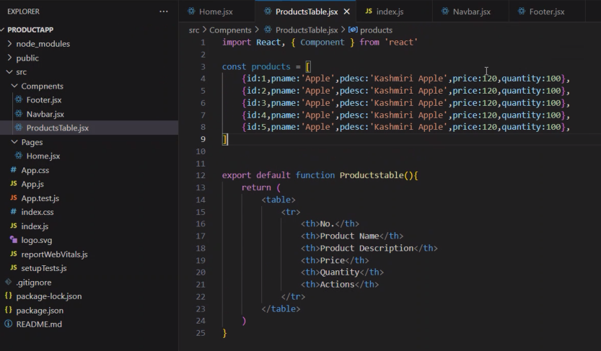

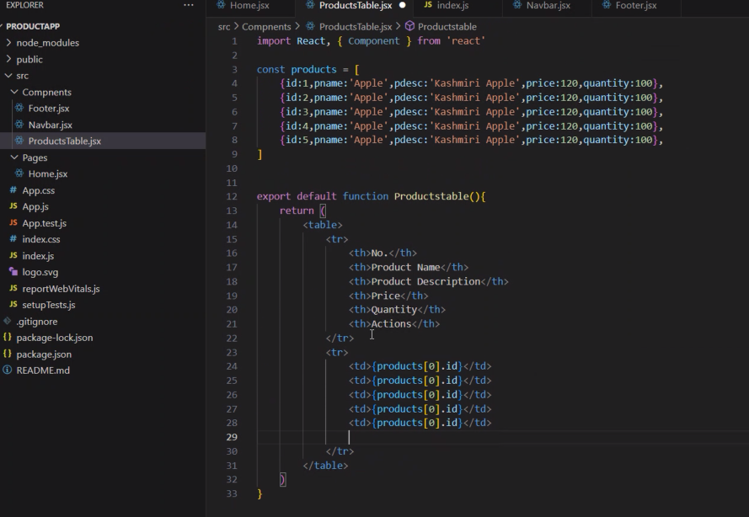

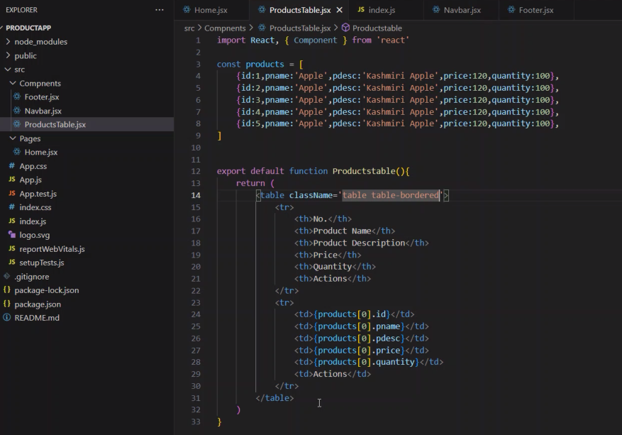

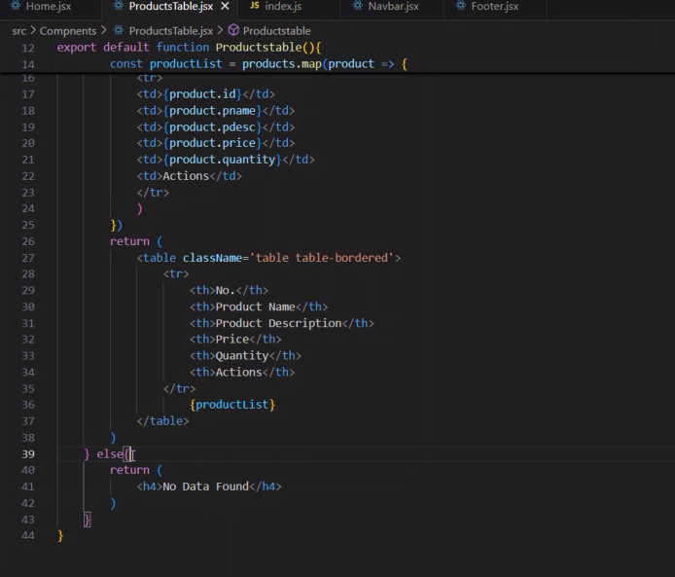

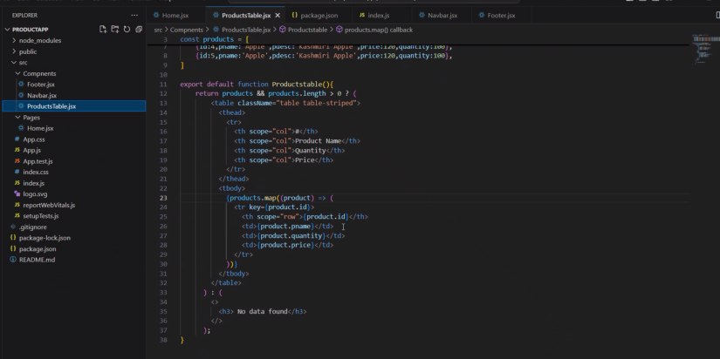

<nav className="navbar navbar-expand-lg bg-body-tertiary">

      <div className="container-fluid">

        <a className="navbar-brand" href="#">

          Navbar

        </a>

        <button

          className="navbar-toggler"

          type="button"

          data-bs-toggle="collapse"

          data-bs-target="#navbarNav"

          aria-controls="navbarNav"

          aria-expanded="false"

          aria-label="Toggle navigation"

        >

          <span className="navbar-toggler-icon"></span>

        </button>

        <div className="collapse navbar-collapse" id="navbarNav">

          <ul className="navbar-nav">

            <li className="nav-item">

              <a className="nav-link active" aria-current="page" href="#">

                Home

              </a>

            </li>

            <li className="nav-item">

              <a className="nav-link" href="#">

                About

              </a>

            </li>

            <li className="nav-item">

              <a className="nav-link" href="#">

                Pricing

              </a>

            </li>

          </ul>

        </div>

      </div>

    </nav>

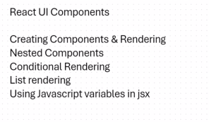

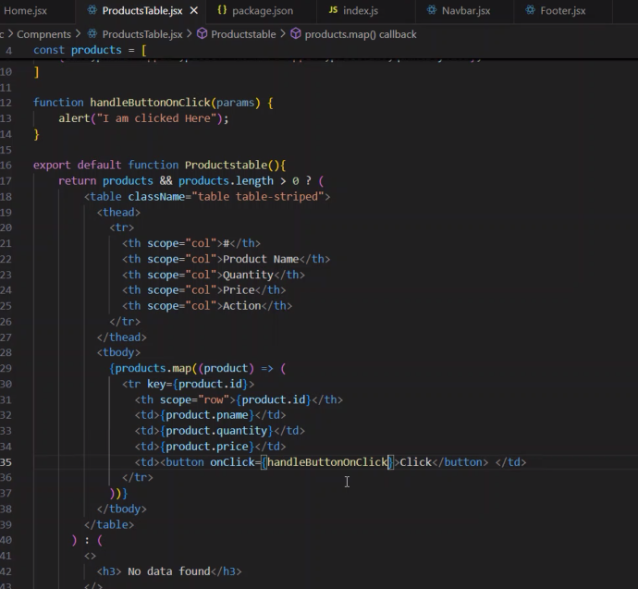

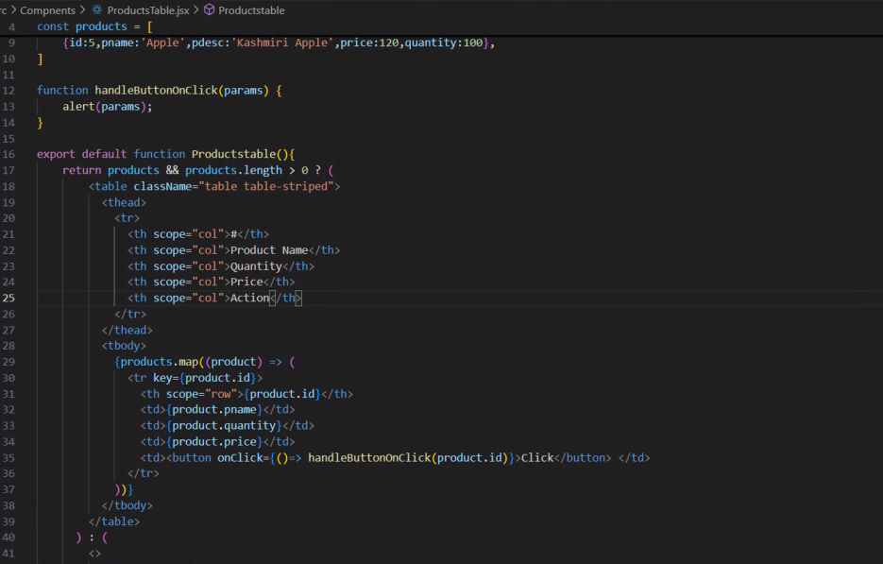

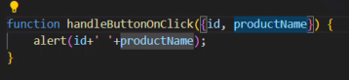

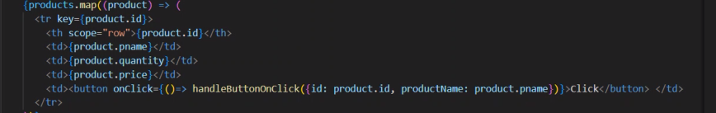

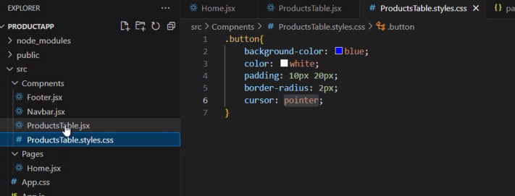



Props or properties components \* - components can have their own properties, like placeholders.

Your can pass properties from parent to child using these components. (share component data)

ParentComponent:

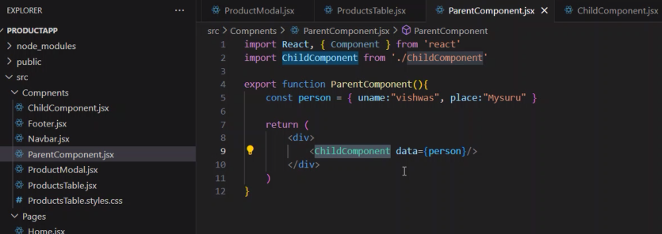

Child Component:

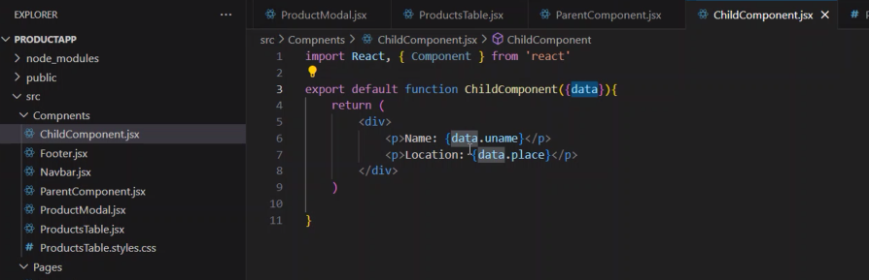

Index.js:

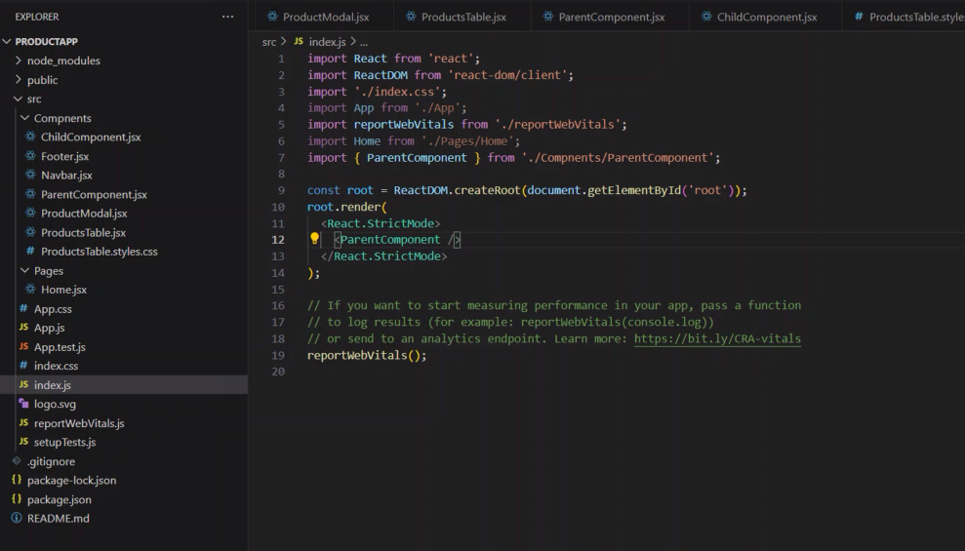

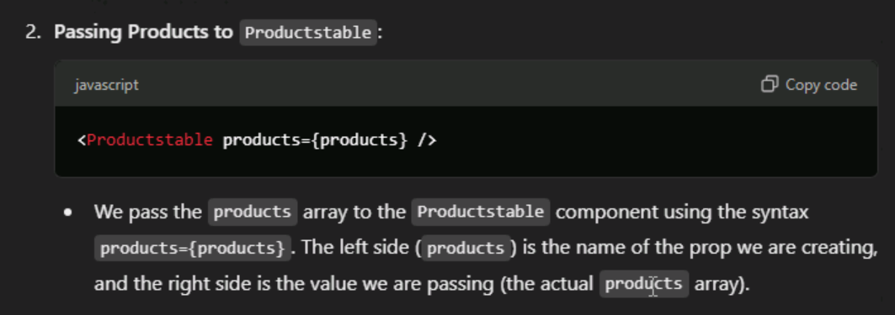

Home.jsx

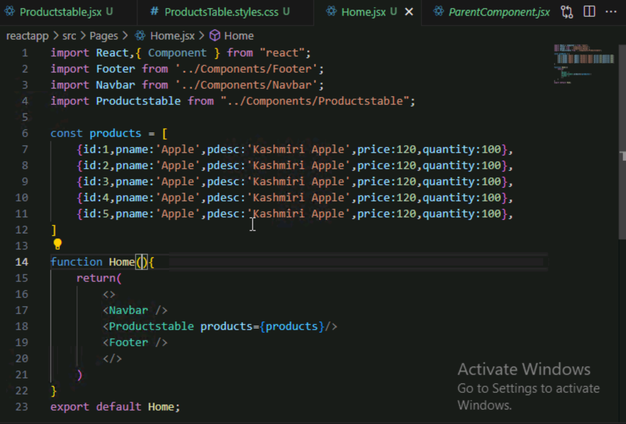Productstable.jsx

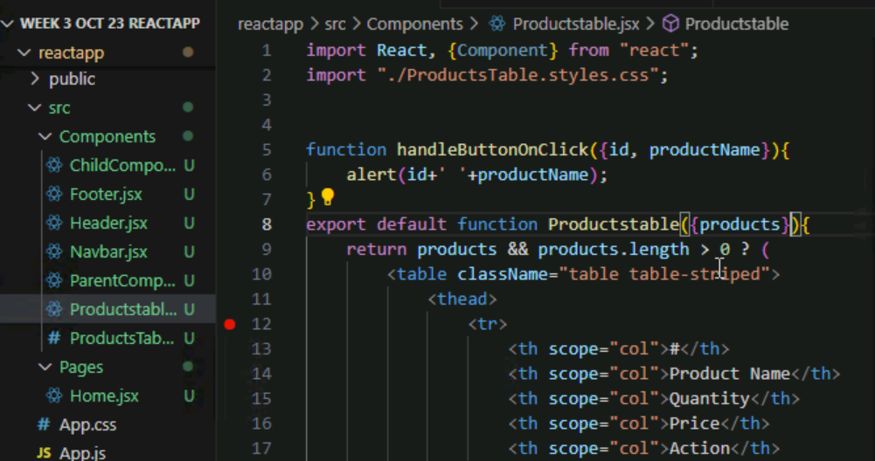

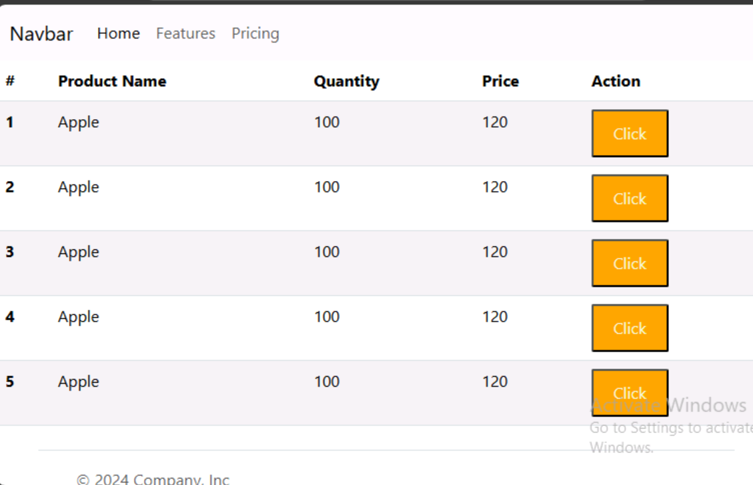

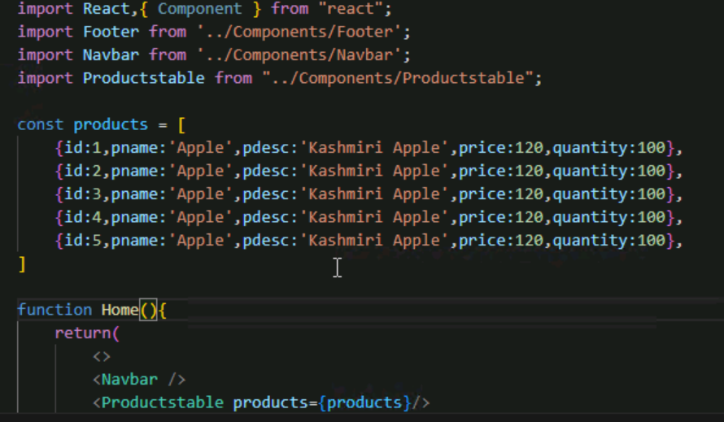

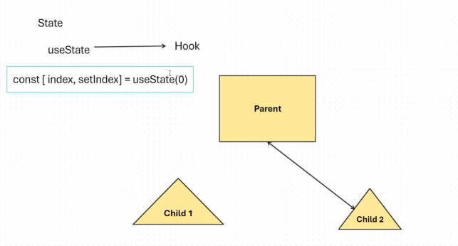

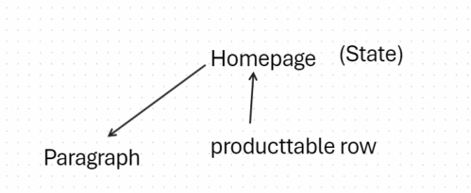

<https://react.dev/learn/state-a-components-memory>

